**Explanation Series Sudoku combined with patterns.**

This Sudoku variant has a number of series, with three numbers each.

At these series the difference between the first and the Second and the Second is and the third number is always identical.

For example:

1 2 3 differences = 1

1 5 9 differences = 4

5 3 1 differences = -2

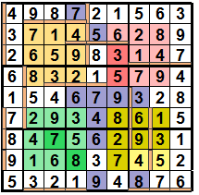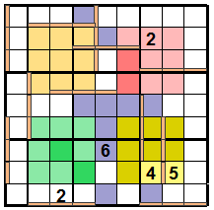

Moreover all normal Sudoku rules apply also to these Sudoku variant.

Horizontal series, always 3 positions long, are indicated with a horizontal beam (under the series):  filled: .

Vertical series, always 3 positions long, are indicated with a vertical beam (left of the series): 

filled: .

The diagonal series (always starting left above and ending Right under and always 3 positions long) are outside the patterns marked in grey: .

Within these patterns the diagonal series are marked in a colour a little bit more dark as the colour of the series itself.

For instance: 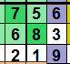 1, 2 and 3 is the diagonal series (7-8-9).

2

3

1

Totally this Sudoku has 7 diagonal, 6 horizontal and 6 vertical series.

**The possible series are:**

1-2-3 1-3-5 1-4-7 1-5-9

2-3-4 2-4-6 2-5-8

3-2-1 3-4-5 3-5-7 3-6-9

4-3-2 4-5-6 4-6-8

5-3-1 5-4-3 5-6-7 5-7-9

6-4-2 6-5-4 6-7-8

7-4-1 7-5-3 7-6-5 7-8-9

8-5-2 8-6-4 8-7-6

9-5-1 9-6-3 9-7-5 9-8-7

There are four Patterns, each 3 by 3 positions::

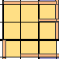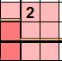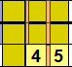All patterns contain the numbers 1 t/m 9 once.

**Solution:**



The diagonal series 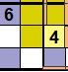 6-?-? Possible series are: 6-4-2, 6-5-4 or 6-7-8.

6-4-2 and 6-5-4 are impossible because row 8 already has the numbers 4 and 5.

So the solution is: 6-7-8.

The vertical series  possible series are: 1-3-5, 2-4-5, 7-6-5 or 9-7-5.

7-6-5 is impossible because row 7 has already a number 7.

2-4-5 is impossible because the Pattern right below already has a number 4. .

9-7- is impossible because the Pattern right below already has a number 7, filled in the first solution. So the solution is: 1-3-5.

Etcetera. .....

The first numbers are mostly found from the series, later on in the solution the numbers are found using the Sudoku rules and the patterns.

Good luck, these puzzles are not simple!!